**How to Create an Azure AD App Registration – Step-By-Step Tutorial**

Azure AD App Registration: Two step-by-step scenarios

Depending on the software, the procedure might be a bit different. In this tutorial, we will cover the two options we use at Connecting Software:

* Client Credentials Grant (via certificate)
* Authorization Code Grant (via client secret)
* Client Credentials Grant
* We’ll first go through the Client Credentials Grant (CCG) procedure, sometimes referred to as implicit grant. Here are the steps you’ll need to follow:
* **CCG1** - Open the [Azure portal](https://portal.azure.com/), log in, and select the **Microsoft Entra ID**

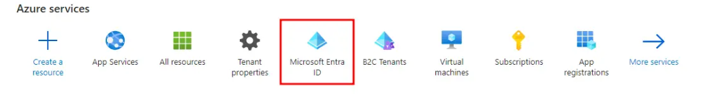

* Alternatively, you can come in through the [Microsoft Entra admin center](https://entra.microsoft.com/) and select **Microsoft Entra ID (Azure AD)**.

CCG2 - Select App registrations.

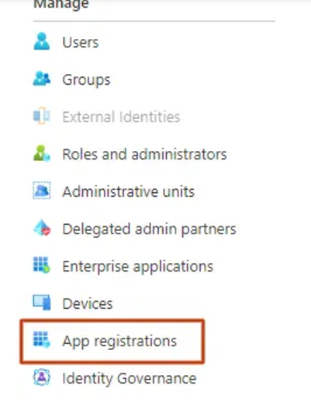

If you came in through the Microsoft Entra Admin Center, you’ll find the **App registrations** under **Applications**.

**CCG3** - Select **New registration**.

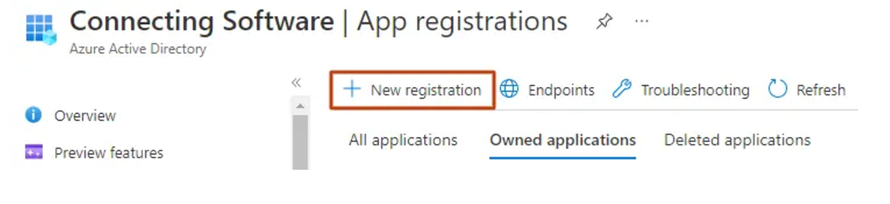

**CCG4** - Type your application’s name, choose the account types and click Register. Please note that the Redirect URI is optional, but necessary in most of the scenarios.

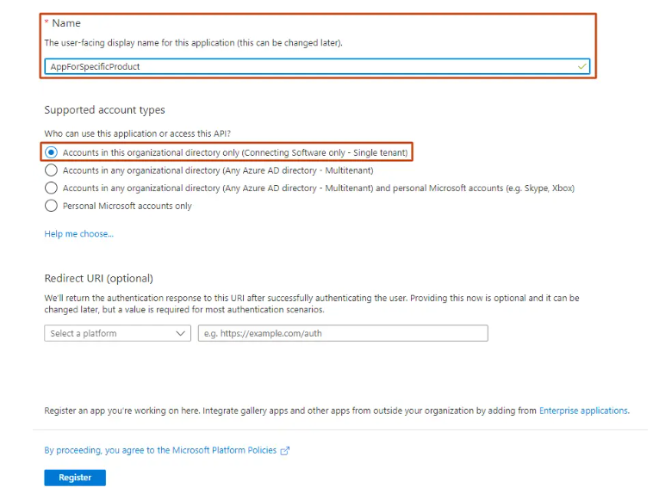

**CCG5** - Copy your **Application (client) ID** and **Directory (tenant) ID** as you will need to enter these in the software you are setting up Modern Authentication in.

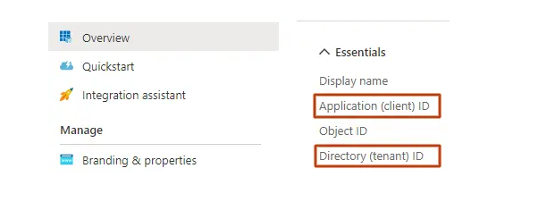

**CCG6** - You will need to get the certificate from the software you are doing Modern Authentication for. As an example, if it is Document Extractor on-premises you can go to the configuration page, download the certificate from the **Public Key Certificate** field. In other cases, you will find it in the **Certificate** field.



CCG7 - You will now upload this certificate in Azure. Click Certificates and secrets, then Certificates, and finally, Upload certificate.

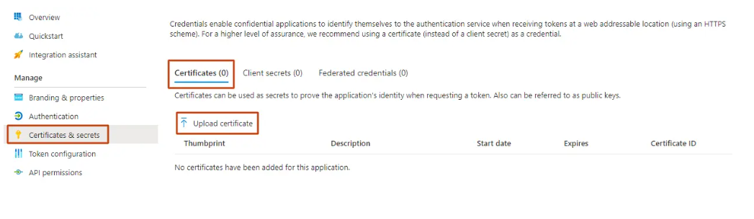

**CCG8** - Upload the certificate which you downloaded earlier and click **Add**.

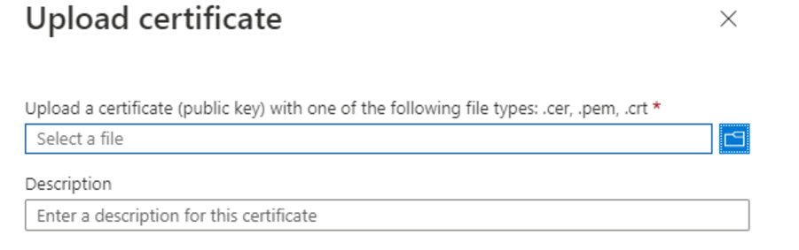

Once uploaded, you should see the certificate in the list, with its **Thumbprint**, **Start date** and an indication of when it **Expires**

**CCG9** - Click **API permissions** and then click on **Add a permission**

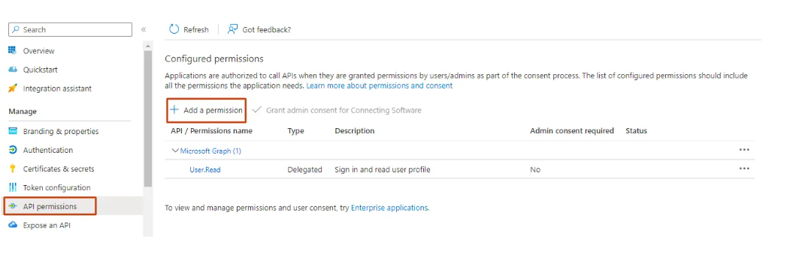

**CCG10** - Select SharePoint and choose **Application permissions**

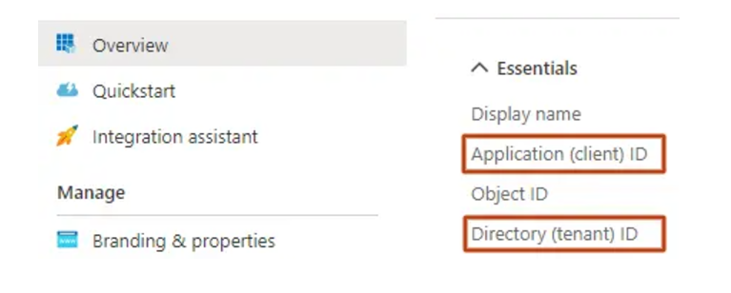

**CCG11** - The permissions you will need to check will depend on the software you are creating the app for and also on your specific use case for it.

This will differ from product to product but, for example, for Document Extractor you would normally check the “Sites.ReadWrite.All” permission, but if you would like to sync changes from SharePoint to Salesforce then you would check the “Sites.Manage.All” permission instead.

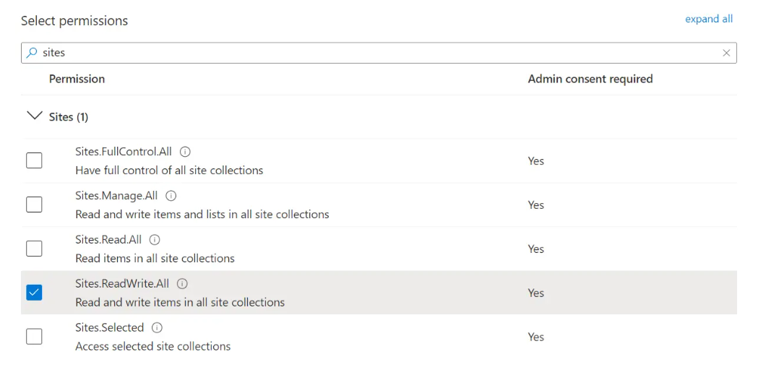

**CCG12** - As a final step you should grant admin consent. You’ll find the **Grant admin consent for …** button next to the **Add a permission** button that you used in the previous step. If the **Grant admin consent for …** is disabled, check which user are you logged in with.

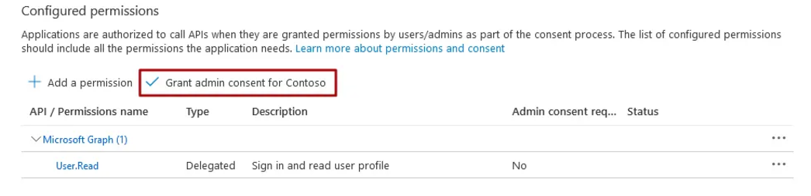

Authorization Code Grant

For this other type of grant, the first steps are identical and then the procedure takes a different path:  
  
**ACG1** - Identical to CCG1  
 **ACG2** - Identical to CCG2  
 **ACG3** - Identical to CCG3  
 **ACG4** - Besides typing your application’s name and choosing the account types, you’ll need to select a platform - select Web - and then enter the redirect URI.  
For example, for CB Dynamics 365 to SharePoint Permissions Replicator, it should be https://permissions-replicator-saas.connecting-software.com/consent-callback.  
Once that is done, click on **Register**.  
 **ACG5** -  In the **Certificates & secrets** section, go to **Client secrets** and click **New client secret**. Copy the generated secret so you can use it in the next steps.

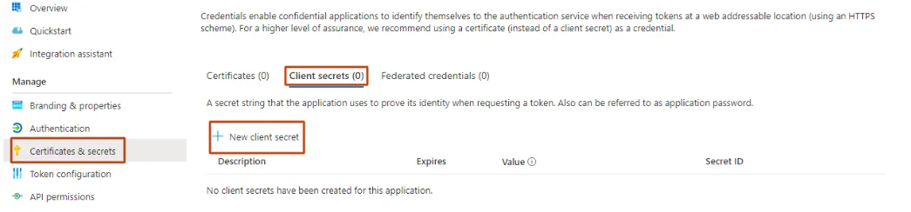

**ACG6** - Identical to CCG9  
 **ACG7** - Identical to CCG10  
 **ACG8** - Identical to CCG11  
 **ACG9** - Identical to CCG12

Conclusion

In this article, we’ve walked you through the two options we use for Azure AD App Registration at Connecting Software: Client Credentials Grant (via certificate) and Authorization Code Grant (via client secret).